If you prefer to edit in Canva, you can also find this template here: https://canva.link/ct9wx3vrludtr7o

Instructions:
- Edit the text boxes in the subsequent page to be relevant to your event, or delete the ones you don’t want.
- Right click the image icon, and select ‘change graphic’ to add your own.
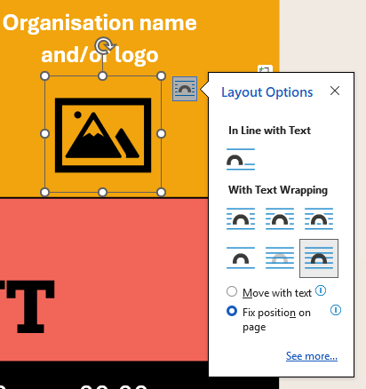
- Add image for any QR codes or other graphics you want to include, and add text box for any new text. Ensure you change text wrapping options and position to ‘fixed position on page’.
- Print only page in use.



Organisation name
and/or logo
Title of
event
With special guests:
Persons Name
Other key information about your event
More key information about your event
$00 / Free
Booking/contact info/Website/ QR code
Ticket Price:
Venue Name
Location address, place
00:00 am – 00:00 pm
00-00 August

